PROJECT REPORT OF CO-OP Project at Industry (Module-2)
ON
AI-Assisted Load Testing and Failure Prediction
submitted in partial fulfilment of the requirements for the award of degree of

BACHELOR OF ENGINEERING
In
COMPUTER SCIENCE AND ENGINEERING

Submitted by: Supervised By:
Aaryan Kansal (2210990014) Dr. Rajat Takkar
Aditya Garg (2210990064) Chitkara University, Punjab



DEPARTMENT OF COMPUTER SCIENCE AND ENGINEERING

CHITKARA UNIVERSITY INSTITUTE OF ENGINEERING AND TECHNOLOGY
CHITKARA UNIVERSITY, PUNJAB, INDIA

CONTENTS

S.No. | Title | Page No.
 | Acknowledgement | iv
 | List of Figures and Tables | v
 | Abstract | vi
1 | Introduction | 7
2 | Methodology | 8-9
3 | Tools and Technologies | 10-11
4 | Implementation | 12-13
5 | Major Findings/Outcomes/Output/Results | 14-16
6 | Conclusion and Future Scope | 17
 | References | 18
 | Appendices | 19

DECLARATION

I hereby certify that the work which is being presented in the project report entitled “AI-Assisted Load Testing and Failure Prediction” in partial fulfilment of requirement for the award of the degree of Bachelor of Engineering (Computer Science and Engineering) submitted in the department of Computer Science and Engineering at Chitkara University Institute of Engineering and Technology, Chitkara University, Punjab, India, is an authentic record of my own work carried out under the supervision of Dr. Rajat Takkar. The matter presented in this project report has not been submitted in any other university/institute for the award of any degree.

Place: Rajpura Aaryan Kansal, Aditya Garg
Date: April 28, 2026 2210990014, 2210990064

This is to certify that the above statement made by the candidate is correct to the best of my knowledge and belief.

Dr. Rajat Takkar
Department of Computer Science and Engineering
Chitkara University Institute of Engineering and Technology,
Chitkara University, Punjab, India

ACKNOWLEDGEMENT
We would like to express our sincere gratitude to all those who supported us throughout the completion of our project titled “AI-Assisted Load Testing and Failure Prediction.”
First and foremost, we would like to thank our project mentor Dr. Rajat Takkar, for providing valuable guidance, continuous encouragement, and constructive suggestions during the development of this project. Their expert advice and constant motivation helped us in understanding the practical aspects of the project and completing it successfully.
We are also thankful to the Department of Computer Science and Engineering, Chitkara University Institute of Engineering and Technology, for providing us with the opportunity and resources required to work on this project as part of our academic curriculum.
We would like to extend our gratitude to all faculty members and our peers who supported us with their suggestions and feedback during the course of this work.
Finally, we are grateful to our families and friends for their unwavering support, encouragement, and motivation throughout the project duration.
This project has been a valuable learning experience for us, enhancing our technical skills and providing practical exposure to load testing, machine learning, anomaly detection, and digital twin simulation.

LIST OF FIGURES AND TABLES

Figure No. | Title | Page No.
Fig. 1 | Latency vs Number of Concurrent Users | 14
Fig. 2 | Actual vs Predicted Latency | 14
Fig. 3 | Failure Probability vs Number of Users | 15
Fig. 4 | Anomaly Detection Results | 15
Fig. 5 | Digital Twin Simulation | 16
List of Figures

ABSTRACT
Modern software applications are expected to handle dynamic user traffic while maintaining high performance and reliability. Traditional load testing techniques are useful for measuring system behaviour under load, but they lack the capability to predict failures before they occur. To address this limitation, this project presents an AI-Assisted Load Testing and Failure Prediction Framework that combines asynchronous load generation, machine learning-based predictive analysis, anomaly detection, and digital twin simulation.
The proposed framework simulates concurrent user traffic on a Flask-based REST API server and collects performance metrics such as latency, throughput, and error rate. These metrics are processed using feature engineering techniques to derive meaningful indicators such as load factor, stress index, and efficiency. Machine learning models including Gradient Boosting Regressor, Random Forest Regressor, and Voting Regressor are trained to predict system latency under different load conditions. In addition, Logistic Regression is used to estimate the probability of system failure, while Isolation Forest detects abnormal performance behaviour.
The trained machine learning models act as a digital twin, enabling simulation of system performance under varying loads without applying actual stress to the production environment. Experimental results show that the framework can accurately predict latency trends, identify anomalies, and estimate failure thresholds, thereby helping developers optimize system performance proactively.
This project demonstrates that integrating artificial intelligence with load testing significantly enhances traditional performance testing by enabling predictive analysis, improving reliability, and reducing the risks associated with system failures in high-traffic environments.

- Introduction

In today’s digital environment, software systems and web applications are expected to serve a large number of users simultaneously while maintaining high availability, reliability, and performance. As the number of concurrent users increases, system resources such as CPU, memory, and network bandwidth experience higher loads, which may lead to increased response times, reduced throughput, and possible system failures. Therefore, load testing plays a vital role in evaluating the performance and stability of applications under varying traffic conditions.
Traditional load testing tools such as Apache JMeter and Locust are commonly used to simulate concurrent user requests and measure system performance metrics such as latency, throughput, and error rate. These tools provide valuable insights into system behaviour during testing, but they are largely reactive in nature, meaning they identify issues only after performance degradation has occurred. They do not provide predictive capabilities to estimate future system behaviour or identify possible failures before they happen.
With the rapid advancement of Artificial Intelligence (AI) and Machine Learning (ML), it has become possible to enhance traditional testing methods by incorporating predictive analytics. Machine learning models can analyze historical performance data, learn the relationship between workload and system behaviour, and predict key metrics such as response latency and failure probability. This enables proactive decision-making and better system optimization.
This project proposes an AI-Assisted Load Testing and Failure Prediction Framework that integrates asynchronous load generation, machine learning-based latency prediction, anomaly detection, and digital twin simulation to improve the efficiency of software performance testing. The framework generates realistic concurrent user traffic against a Flask-based API server and collects key performance metrics including response time, throughput, and error rate. These metrics are processed through feature engineering to derive additional indicators such as load factor, stress index, and efficiency, which are then used to train predictive machine learning models.
The trained models serve as a digital twin of the system, allowing the prediction of system behaviour under different load conditions without applying actual stress to the production environment. Additionally, anomaly detection techniques identify abnormal system behaviour, while failure prediction models estimate the maximum load the system can sustain before failure.
The objective of this project is to create an intelligent load testing framework that not only evaluates current system performance but also predicts future failures and performance bottlenecks. By integrating AI with load testing, the proposed framework helps developers improve system reliability, optimize resources, and reduce the risks associated with unexpected service failures in high-traffic applications.

- Methodology

The AI-Assisted Load Testing and Failure Prediction Framework follows a structured approach to simulate system load, collect performance data, and apply machine learning models for predictive analysis. The methodology includes the following stages:

2.1 Load Generation

A Flask-based REST API server is used as the system under test. To simulate concurrent users, an asynchronous load generator is implemented using asyncio and aiohttp. This allows multiple requests to be sent simultaneously, creating realistic traffic conditions and helping evaluate the system under different load levels.

2.2 Performance Data Collection
During load testing, important performance metrics are recorded, including:
- Latency
- Throughput
- Error Rate
- Concurrent Users
These metrics are stored in a dataset for further analysis and model training.

2.3 Feature Engineering
Additional features such as load factor, stress index, and efficiency are derived from the collected metrics. These features improve the machine learning model’s ability to understand the relationship between system load and performance.

2.4 Machine Learning Model Training
The processed dataset is used to train machine learning models such as Gradient Boosting Regressor, Random Forest Regressor, and Voting Regressor to predict system latency under different workloads.
For failure prediction, Logistic Regression is used to estimate the probability of system failure based on system performance metrics.

2.5 Anomaly Detection
The framework uses Isolation Forest to detect abnormal behaviour in system performance, such as sudden latency spikes or unexpected failures. This helps identify performance issues before the system reaches failure.

2.6 Digital Twin Simulation
The trained machine learning models act as a digital twin, simulating system behaviour under different loads. This helps predict latency and failure thresholds without applying actual stress to the production environment.

2.7 Result Analysis
The outputs are analyzed using visualizations such as Latency vs Users, Predicted vs Actual Latency, and Failure Probability graphs to evaluate system behaviour and validate prediction accuracy.

- Tools and Technologies

The development of the AI-Assisted Load Testing and Failure Prediction Framework involved the use of several tools and technologies for API development, load generation, data processing, machine learning, and result visualization.

3.1 Python
Python was used as the primary programming language for implementing the entire framework. It provided strong support for asynchronous programming, machine learning libraries, and data analysis tools, making it suitable for building the load testing and prediction system.

3.2 Flask
Flask was used to develop the REST API server that acted as the system under test. It provided lightweight and efficient API endpoints for simulating real-world server behaviour during load testing.

3.3 Asyncio and Aiohttp
The asyncio and aiohttp libraries were used to create the asynchronous load generator. These tools enabled the simulation of multiple concurrent users by sending parallel HTTP requests, allowing efficient load testing with minimal overhead.

3.4 Pandas
Pandas was used for storing, organizing, and processing the performance data collected during load testing. It helped in creating structured datasets and performing feature engineering for machine learning.

3.5 Scikit-learn
Scikit-learn was used for implementing machine learning models such as:
- Gradient Boosting Regressor
- Random Forest Regressor
- Voting Regressor
- Logistic Regression
- Isolation Forest
These models were used for latency prediction, failure prediction, and anomaly detection.

3.6 Matplotlib
Matplotlib was used to visualize the experimental results through graphs such as latency trends, prediction comparisons, failure probability curves, and anomaly detection results. These visualizations helped in analyzing the system performance effectively.

3.7 Jupyter Notebook / VS Code
The development and testing of the framework were carried out using Jupyter Notebook and Visual Studio Code, which provided a convenient environment for coding, model training, debugging, and result analysis.

- Implementation
The implementation of the AI-Assisted Load Testing and Failure Prediction Framework was carried out in multiple stages, including API development, asynchronous load generation, data collection, machine learning integration, and result visualization.

4.1 API Server Development
A Flask-based REST API server was developed to act as the target system for load testing. The server handled basic API requests and simulated real-world application behaviour under concurrent traffic conditions. This API served as the environment for collecting system performance metrics during testing.

4.2 Asynchronous Load Generation
An asynchronous load generator was created using asyncio and aiohttp to simulate multiple users sending requests to the API server simultaneously. The number of concurrent users was increased gradually to observe how the system responded under varying loads.
This approach made the load testing process efficient and scalable while generating realistic traffic patterns.

4.3 Performance Data Collection
During execution, the framework recorded important system metrics such as:
- Latency
- Throughput
- Error Rate
- Concurrent Users
The collected data was stored in a structured format for further processing and analysis.

4.4 Feature Engineering and Model Training
The collected performance metrics were processed to derive additional features such as load factor, stress index, and efficiency. These features were used to train machine learning models for latency prediction and failure estimation.
Regression models like Gradient Boosting Regressor, Random Forest Regressor, and Voting Regressor were trained to predict latency, while Logistic Regression was used for failure prediction.
4.5 Anomaly Detection
The Isolation Forest algorithm was implemented to detect abnormal system behaviour during load testing. It identified unusual spikes in latency and other irregular performance patterns, helping detect possible system issues before failure.

4.6 Digital Twin Simulation
The trained machine learning models were used as a digital twin to simulate system behaviour under different load scenarios. This enabled prediction of system latency and failure thresholds without putting actual stress on the live environment.

4.7 Result Visualization
The final outputs were visualized using graphs generated with Matplotlib, including:
- Latency vs Concurrent Users
- Actual vs Predicted Latency
- Failure Probability vs Users
- Anomaly Detection Results
These visualizations helped evaluate the accuracy of predictions and overall system performance.

- Major Findings/Outcomes/Output/Results
The experimental results obtained from the AI-Assisted Load Testing and Failure Prediction Framework demonstrated the effectiveness of combining load testing with machine learning for predictive performance analysis.

5.1 System Performance Under Load
During load testing, the system performed efficiently under low and moderate user loads, maintaining low latency and minimal error rates. However, as the number of concurrent users increased, the system showed a gradual rise in response latency and error rate, indicating increased stress on system resources.
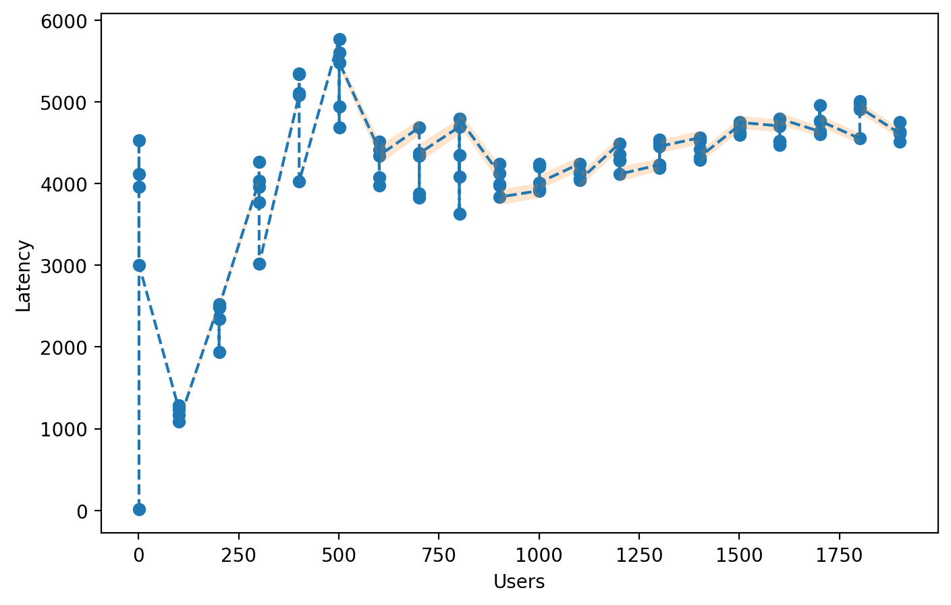
This behaviour helped identify the load range within which the system operated reliably.
Fig. 1: Latency vs Number of Concurrent Users

5.2 Latency Prediction Accuracy
The machine learning models were able to predict system latency with good accuracy based on the collected performance metrics. Among the regression models used, the Voting Regressor produced the most accurate results by combining the predictions of multiple models.
The comparison between actual latency and predicted latency showed a close match, validating the effectiveness of the predictive model.
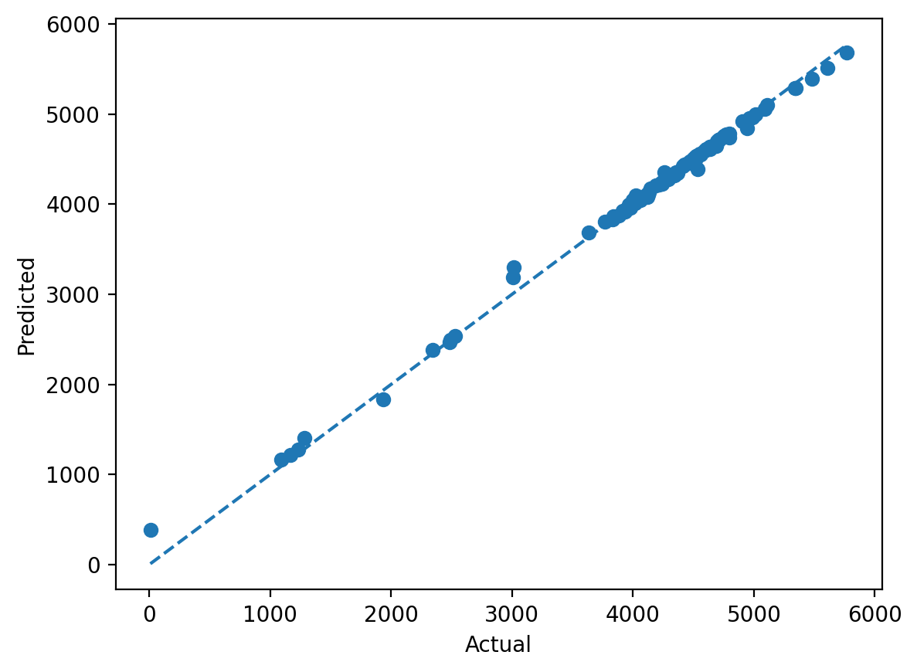

Fig. 2: Actual vs Predicted Latency

5.3 Failure Threshold Estimation
The Logistic Regression model successfully estimated the probability of system failure as the load increased. The results showed that the framework could identify the approximate maximum number of concurrent users the system could handle before performance degradation became critical.
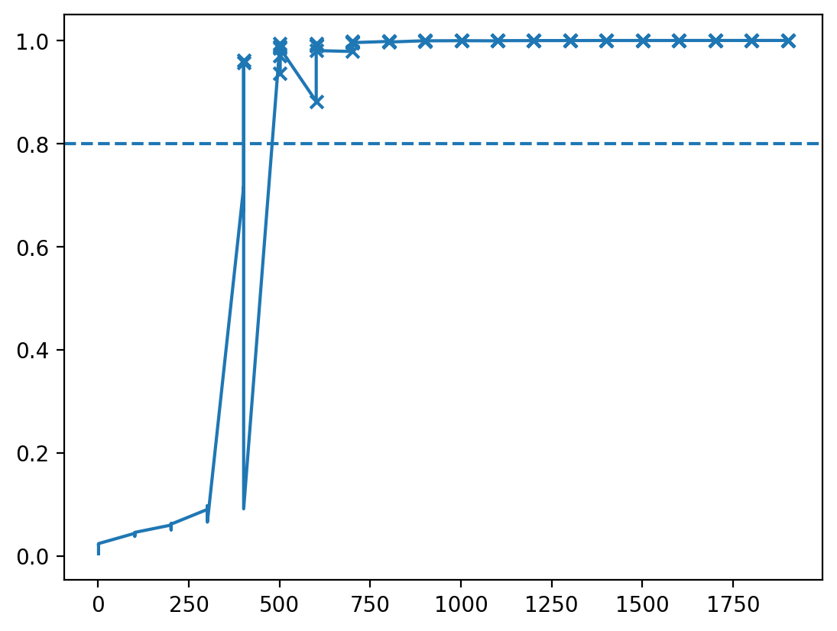
This prediction helps in planning system capacity and avoiding unexpected failures.

Fig. 3: Failure Probability vs Number of Users

5.4 Anomaly Detection
The Isolation Forest algorithm effectively detected abnormal system behaviour such as sudden spikes in latency and unusual performance patterns. This enabled early identification of performance bottlenecks and potential failures.
Anomaly detection improved the reliability of the framework by providing proactive alerts before complete system breakdown.
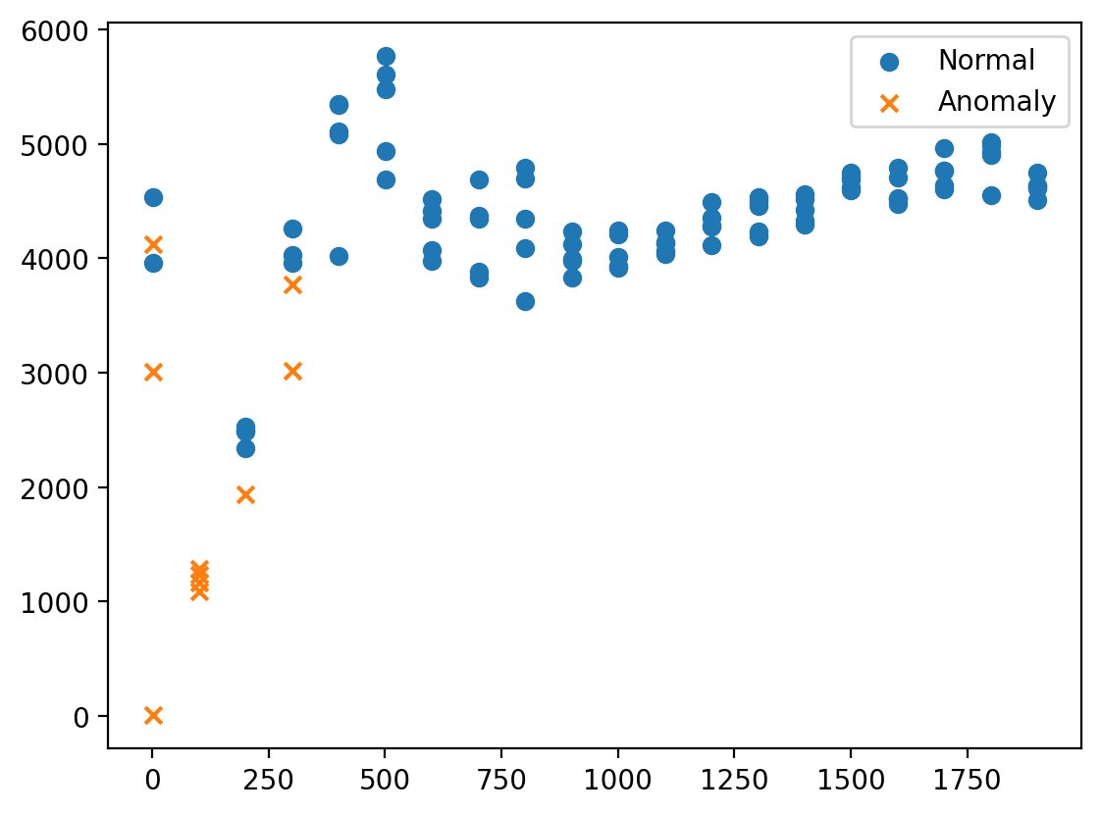

Fig. 4: Anomaly Detection Results

5.5 Digital Twin Simulation Results
The digital twin simulation successfully modeled system behaviour under varying loads using the trained machine learning models. This allowed prediction of system performance without applying high stress on the actual environment.
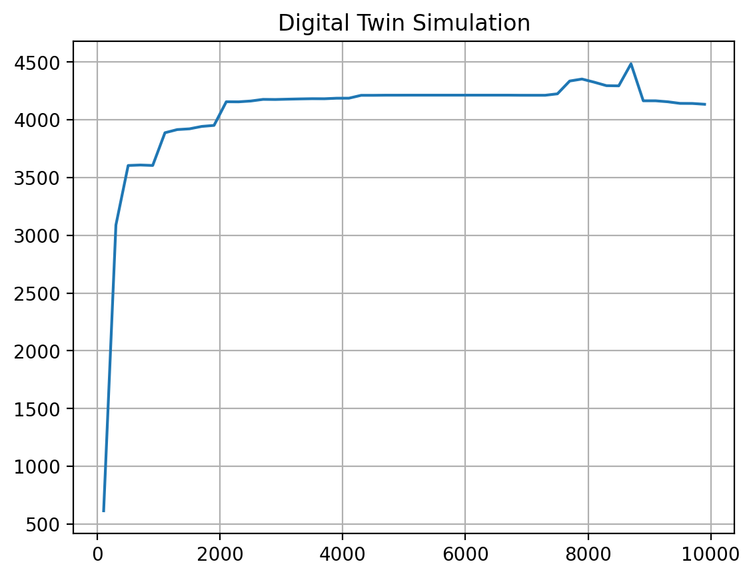
The simulation results were useful for evaluating future load scenarios and estimating performance limits safely.

Fig. 5: Digital Twin Simulation

5.6 Overall Outcome
The overall implementation proved that integrating machine learning with load testing significantly improves the traditional performance testing process by enabling:
- Accurate latency prediction
- Failure probability estimation
- Early anomaly detection
- Safe performance simulation using digital twin models
This framework provides developers with proactive insights for optimizing system performance and improving application reliability.

- Conclusion and Future Scope
The AI-Assisted Load Testing and Failure Prediction Framework successfully demonstrated how artificial intelligence can improve traditional software performance testing. By combining asynchronous load generation, machine learning-based prediction, anomaly detection, and digital twin simulation, the framework was able to analyze system behaviour under varying workloads and predict possible performance issues in advance.
The experimental results showed that the system could accurately predict response latency, detect abnormal behaviour, and estimate failure thresholds with good reliability. This proactive approach helps developers identify performance bottlenecks early and optimize system resources before actual failures occur.
The integration of a digital twin model further enhanced the framework by allowing simulation of system performance under different load conditions without stressing the live environment. This reduces the risk associated with high-load testing and improves system reliability.

6.1 Future Scope
The project can be further enhanced in the following ways:
- Extending the framework to support distributed microservices architectures
- Integrating real-time monitoring and auto-scaling mechanisms
- Applying deep learning models for more accurate performance prediction
- Expanding support for cloud-based deployment environments
- Building a real-time dashboard for monitoring latency, anomalies, and failure probability
These improvements can make the framework more scalable, intelligent, and suitable for enterprise-level performance testing applications.

References

[1] Flask Documentation, “Flask Web Development Framework”
Available: https://flask.palletsprojects.com/

[2] aiohttp Documentation, “Asynchronous HTTP Client/Server for Python”
Available: https://docs.aiohttp.org/
[3] asyncio Documentation, “Asynchronous I/O in Python”
Available: https://docs.python.org/3/library/asyncio.html
[4] Pandas Documentation, “Data Analysis and Manipulation Tool”
Available: https://pandas.pydata.org/
[5] Scikit-learn Documentation, “Machine Learning in Python”
Available: https://scikit-learn.org/
[6] Matplotlib Documentation, “Visualization with Python”
Available: https://matplotlib.org/
[7] Apache JMeter User Manual, “Performance Testing Tool”
Available: https://jmeter.apache.org/

APPENDICES

The appendices section contains supplementary materials related to the implementation and testing of the AI-Assisted Load Testing and Failure Prediction Framework.

Appendix A: Sample API Endpoints
This appendix includes the sample Flask API endpoints used as the target system during load testing.

Appendix B: Load Testing Scripts
This appendix contains the asynchronous load generation scripts implemented using asyncio and aiohttp to simulate concurrent user requests.

Appendix C: Machine Learning Models
This appendix includes the implementation details of the regression, classification, and anomaly detection models used in the framework.

Appendix D: Experimental Graphs
This appendix contains graphs generated during experimentation, including:
- Latency vs Number of Concurrent Users
- Actual vs Predicted Latency
- Failure Probability vs Number of Users
- Anomaly Detection Results
- Digital Twin Simulation Output

Appendix E: Dataset Sample
This appendix provides sample performance data collected during load testing, including latency, throughput, error rate, and derived features.

